Exercise 3 – Implementing the Builder Pattern

Scenario
Develop a system to create complex Computer objects with optional configurations using the Builder Pattern.

Understanding the Builder Pattern
The Builder Pattern separates the construction of a complex object from its representation. It allows different configurations to be created using the same construction process.

Project Name
BuilderPatternExample

Implementation
class Computer {
private String cpu;
private String ram;
private String storage;
private Computer(Builder builder){
this.cpu = builder.cpu;
this.ram = builder.ram;
this.storage = builder.storage;
}
public void display(){
System.out.println("CPU : " + cpu);
System.out.println("RAM : " + ram);
System.out.println("Storage : " + storage);
}
static class Builder{
private String cpu;
private String ram;
private String storage;
Builder setCPU(String cpu){
this.cpu = cpu;
return this;
}
Builder setRAM(String ram){
this.ram = ram;
return this;
}
Builder setStorage(String storage){
this.storage = storage;
return this;
}
Computer build(){
return new Computer(this);
}
}
}
public class BuilderTest{
public static void main(String[] args){
Computer computer = new Computer.Builder()
.setCPU("Intel i7")
.setRAM("16 GB")
.setStorage("512 GB SSD")
.build();
computer.display();
System.out.println("\nComputer built successfully using Builder Pattern.");
}
}

Sample Output
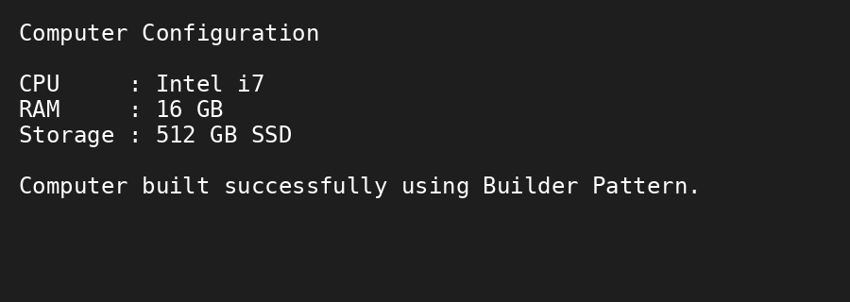

Conclusion
The Builder Pattern simplifies the creation of complex objects by providing a flexible and readable object construction process.

